ATC 600 Series Measurement Notes and Test Conditions

This describes the applicable test conditions and equipment used in the measurement of scattering parameters for the ATC 600 series capacitors.

Note that S-parameters are dependent on the particular substrate (dielectric constant and thickness) as well as the pad/trace size -- and the capacitor orientation, horizontal or vertical. Unless the conditions of use are very similar to those in ATC’s standard measurement setup, or the operating frequency is so low that none of the above matters very much, there is the possibility that S-parameter measurements may be more misleading than helpful. In the general case, customers might consider consulting with Modelithics for the availability of models that provide substrate-dependent, pad scalable, orientation-selectable S-parameters.

In ATC’s test setup, each capacitor was mounted in a series configuration on microstrip. As shown below, each unit under test (UUT) subtended a “G”-mil gap in a “W”-mil wide trace on Rogers 4350 softboard, “T” mils thick. “G,” “W,” and ”T” are given in Table 1 for various-size capacitors. In general, “W” was kept at about the width of the capacitor, with “T” selected to make the trace width a 50-ohm line.

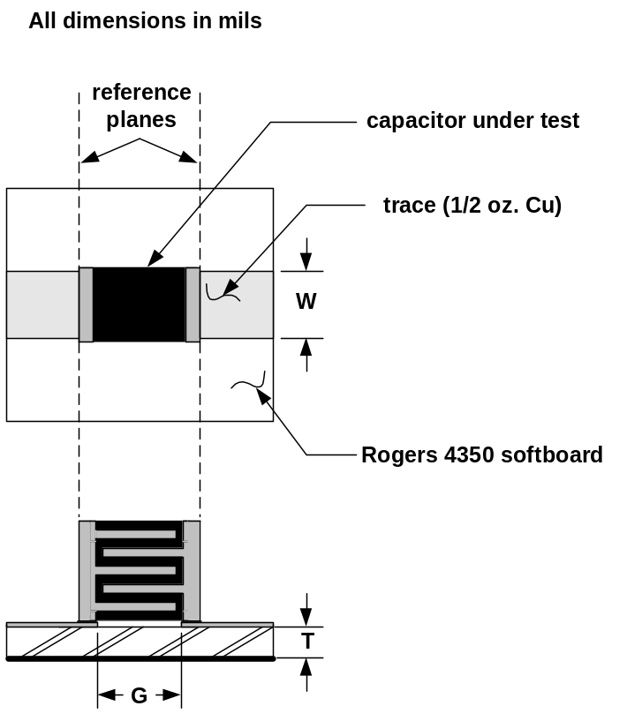

Case Size | G (mils) | W(mils) | T(mils)
0402 | 24 | 22 | 10
0603 | 36 | 29 | 13.3
0805 | 46 | 52 | 23.3

All measurements were made using an Anritsu 3680K Universal Test Fixture and a Vector Network Analyzer having a four-receiver architecture. Measurements have been de-embedded to the edges of the capacitor under test using a standard TRL calibration procedure. (I.e., S-parameters are referenced at the edges of each capacitor.)

The following is a data sample:

# HZ S DB R 50
400000000 -.0582 -7.9651 -19.173 81.672 -19.172 81.549 -.0328 -8.3414
465000000 -.0650 -9.1681 -17.89 80.394 -17.893 80.167 -.0647 -9.8204
530000000 -.1505 -10.25 -16.795 79.305 -16.755 78.665 -.0610 -10.859
595000000 -.1587 -12.058 -15.817 77.855 -15.807 78.213 -.1318 -11.022

The first line is a header, designated by the “#” character. Succeeding characters describe respectively the frequency units, parameter, measurement format, and characteristic impedance of the measurement system (in this case 50 ohms). The data is arranged as follows: The first column is the frequency in Hz. The next two columns are S11 magnitude (in db) and S11 phase (in degrees). Succeeding column pairs represent S21, S12, and S22.

The lowest measured frequency is 400 MHz. An artificial point at 0 frequency has been added to some scattering matrices to avoid problems encountered when using certain software simulators. The highest measured frequency varies; it is generally selected to include at least the first parallel resonance frequency (see below), and often the second. In general, customers are advised to be cautious when using software simulation since many programs attempt to extrapolate measured data both below and above actual measurement frequencies – and often arrive at grossly incorrect results. If in doubt, customers are advised to examine particular scattering matrices in a word processor or other suitable program to determine actual upper and lower measured frequencies.

For passive devices, the magnitude of each S-parameter must be equal to or less than unity, i.e., when expressed in dB, it must be ≤ 0. However, because of small, unavoidable errors in the TRL calibration, the magnitudes of some measured S-parameters near zero-dB are on rare occasions slightly positive. In the published scattering matrices, each of these elements is assigned a value of -0.01 dB.

It may be noted that ATC extracts resonant frequency data-sheet information from the measured scattering matrices, using the following definitions:

- First Series Resonance (FSR) is the lowest frequency at which the input reactance, referenced at the capacitor edge, becomes zero ohms -- provided that, up to that point, both real and reactive parts of the input impedance exhibit essentially monotonic behavior. Should the monotonicity condition be violated, the FSR is undefined.

- First Parallel Resonance (FPR) is the lowest frequency at which there is a notch or suck-out in the S21 magnitude response. If the notch is very small, e.g. 0.1 dB, or indistinct (as may occur with lossy devices), an attempt is made to verify a suspected FPR by examining the phase response of the reactance or of S11 at the frequency of interest. If results are still inconclusive, no FPR frequency is assigned to the device.
It may further be observed that the lowest zero-Ohm reactance frequency will, in general, be different for the series-through and shunt-to-ground configurations. This can be readily verified by short-circuiting the output of the two-port network having a scattering matrix derived from the former data. Comparing the input reactance vs. frequency (or Smith Chart) plots to those derived from terminating the output port with a 50-Ohm resistor, it will be seen that the first zero-crossings are not the same.

DISCLAIMER: American Technical Ceramics (ATC) has made every effort to
make this information as accurate as possible. However, no responsibility
is assumed by ATC for its use, nor any infringements of rights of third
parties which may result from its use. ATC reserves the right to revise
the content or modify its product line without prior notice.

